**Format keyword**

print('{0},{1},{2}'.format('apple','banana','carrot','pen'))

print('{},{},{}'.format('apple','banana','carrot'))

print('{2},{1},{0}'.format('apple','banana','carrot'))

print('{2},{1},{1},{0}'.format('apple','banana','carrot'))

print('{2},{1},{0}'.format(*'abcd'))

print('{0},{1},{0}'.format('apple','banana','carrot'))

print('Coordinate:{latitude},{longitude}'.format(latitude='37.24N',longitude='-115.81W'))

print('Welcome:{name},your college is:{college}'.format(name='Harsh',college='IMS UC'))

**OUTPUT**

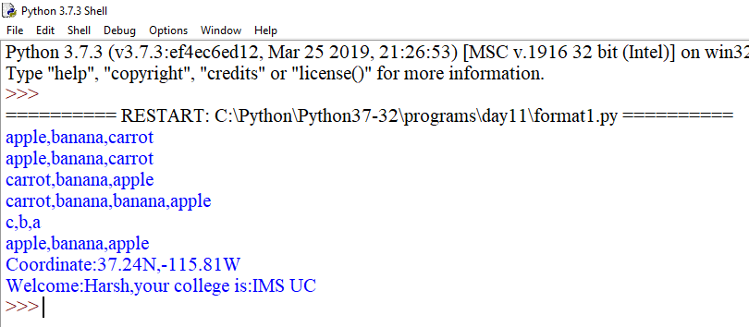

coord={'latitude':'37.24N','longitude':'-115.81W'}

print('Coordinates:{latitude},{longitude}'.format(**coord))

c=3-5j

print('The complex number {0} is formed from the real\

part{0.real} and the imaginary part{0.imag}'.format(c))

coord=(3,5)

abc=(2,9)

print('X:{0[0]};Y:{0[1]};abc{1[0]},{1[1]}'.format(coord,abc))

coord=[(3,9),(2,4)]

print('first tuple:{0[0]},{0[1]},second tuple:{1[0]},{1[1]}'.format(*coord))

print('{:#<30}'.format('Apple'))#left aligned

print('{:*>30}'.format('Apple'))#right aligned

print('{:^30}'.format('Apple'))#centered aligned

print('{:*^30}'.format('Apple'))

print("int: {0:d}; hex: {0:x}; oct: {0:o}; bin: {0:b}".format(42,55))

print("int: {1:d}; hex: {1:x}; oct: {1:o}; bin: {1:b}".format(42,55))

print('{:,}'.format(1234567890))

points=19.0;total=22

print('Correct answers:{:.4%}'.format(points/total))

**OUTPUT**